**MODUL 13 PEMROGRAMAN BERORIENTASI OBJEK**

**NETWORKING BAGIAN 1**

1. Source Code

Github: <https://github.com/afrzl/Pemrograman-Berorientasi-Objek/tree/main/Week%2013/Praktikum/Latihan%20Server/src>

1. LatihanServer.java

import java.io.BufferedReader;  
import java.io.IOException;  
import java.io.InputStreamReader;  
import java.io.PrintWriter;  
import java.net.ServerSocket;  
import java.net.Socket;  
import java.util.logging.Level;  
import java.util.logging.Logger;  
  
  
public class LatihanServer {  
 */**  
 * @param args the command line arguments  
 */* public static void main(String[] args) {  
 // *TODO code application logic here* int portNumber = 4444;  
 try (  
 ServerSocket serverSocket = new ServerSocket(portNumber);  
 Socket clientSocket = serverSocket.accept();  
 PrintWriter out = new PrintWriter(clientSocket.getOutputStream(), true);  
 BufferedReader in = new BufferedReader(new InputStreamReader(clientSocket.getInputStream()));  
 )  
 {  
 String msg;  
 while(!(msg = in.readLine()).equalsIgnoreCase("exit"))  
 {  
 System.*out*.println("Server Receive: " + msg);  
 out.println("Pesan Diterima");  
 }  
 } catch (IOException ex) {  
 Logger.*getLogger*(LatihanServer.class.getName()).log(Level.*SEVERE*, null, ex);  
 }  
 }  
  
}

1. LatihanClient.java

import java.io.BufferedReader;  
import java.io.IOException;  
import java.io.InputStreamReader;  
import java.io.PrintWriter;  
import java.net.Socket;  
import java.util.logging.Level;  
import java.util.logging.Logger;  
  
  
public class LatihanClient {  
 public static void main(String args[]){  
 String hostName = "localhost";  
 int portNumber = 4444;  
 try (  
 Socket echoSocket = new Socket(hostName, portNumber);  
 PrintWriter out = new PrintWriter(echoSocket.getOutputStream(),true);  
 BufferedReader in = new BufferedReader(new InputStreamReader(echoSocket.getInputStream()));  
 BufferedReader stdIn = new BufferedReader(new InputStreamReader(System.*in*));  
 )  
 {  
 String msg;  
 while((msg = stdIn.readLine()) != null)  
 {  
 out.println(msg);  
 if(msg.equalsIgnoreCase("exit")) break;  
 System.*out*.println("Client receive: "+ in.readLine());  
 }  
 } catch (IOException ex) {  
 Logger.*getLogger*(LatihanClient.class.getName()).log(Level.*SEVERE*, null, ex);  
 }  
 }  
}

1. Output
2. LatihanClient

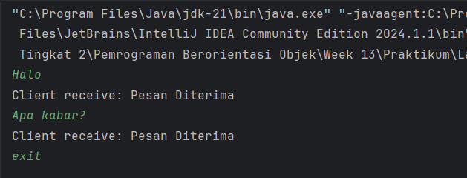

1. LatihanServer

